In the file src\router\index.js

Each item should have this attributes rol and permission

meta: {

requiresAuth: true,

rol: [1,3],

permission:'change-profile',

},

The rol atibutte is only for super admin and corporate account,

The permission attribute is for the rest of roles

The persimission table is “permissions” the app will get the “slug” attribute in the app

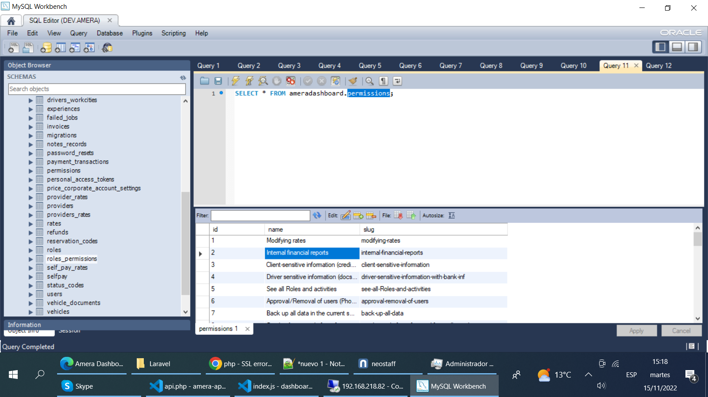

To add a permission to a role is in the table “roles_permissions”

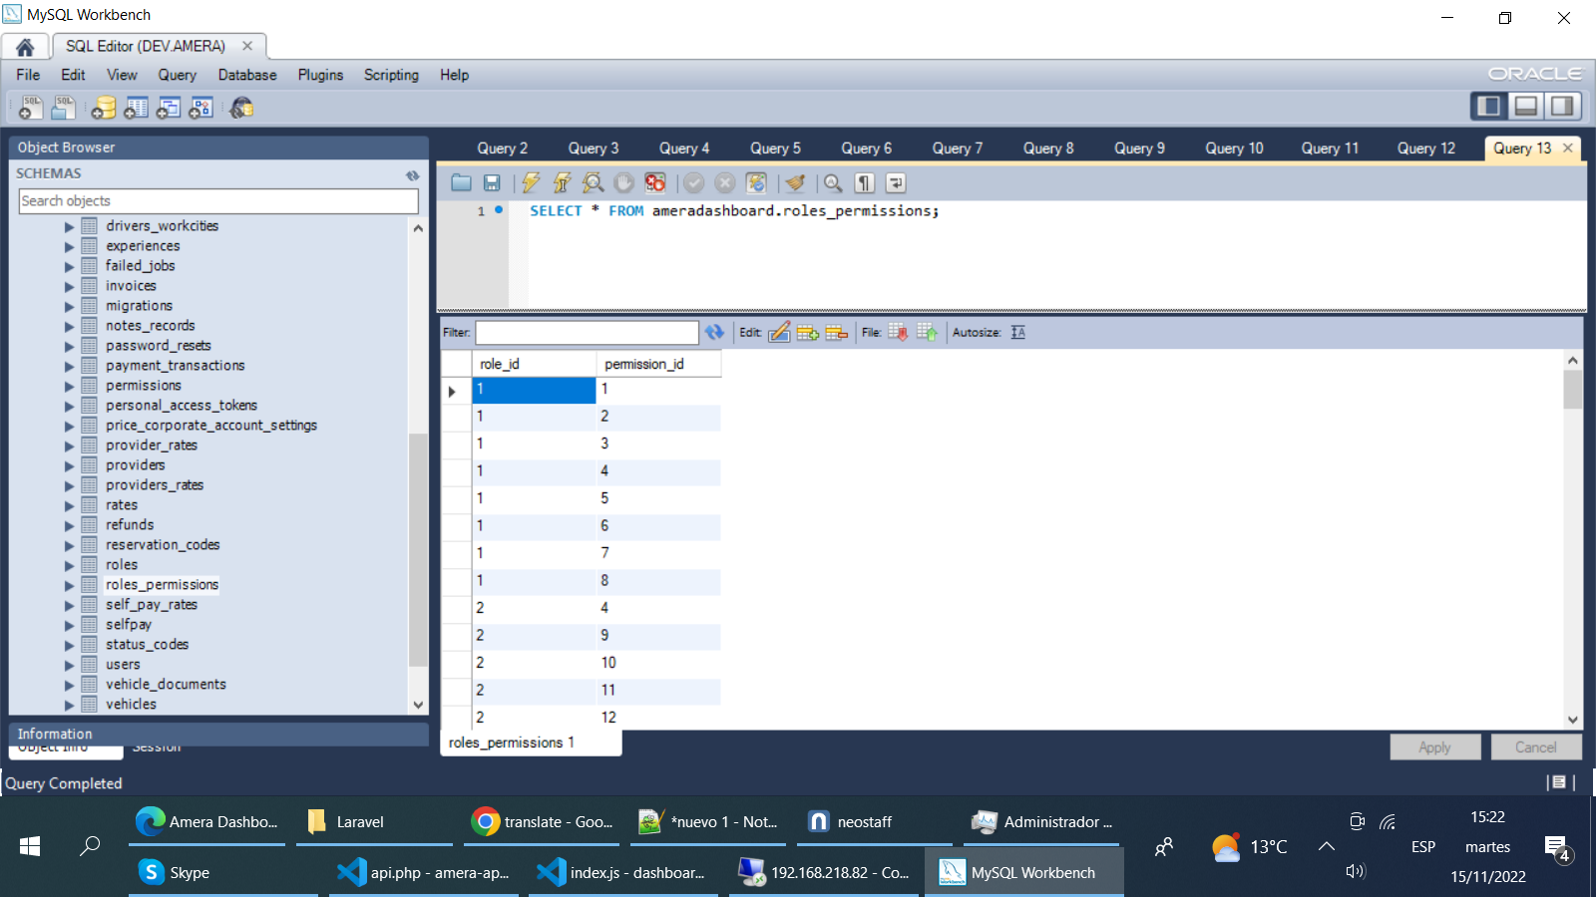

In the file src\navigation\vertical\infosuperadmin.js

The configuration will be the same, each item should have this attributes rol and permission

The rol atibutte is only for super admin and corporate account,

The permission attribute is for the rest of roles

{

        title: 'Booking center',

        route: 'home-corporate-acount',

        icon: 'HomeIcon',

        meta: {

            requiresAuth: true,

            role: ROL_SUPER_ADMIN,

            permission: null,

        },

        children: [{

                title: 'Dispatch',

                route: 'reservations',

                meta: {

                    requiresAuth: true,

                    role: ROL_SUPER_ADMIN,

                    permission: 'dispatch-board',

                },

            },

            {

                title: 'Book a Ride',

                route: 'book-a-ride',

                meta: {

                    requiresAuth: true,

                    role: ROL_SUPER_ADMIN,

                    permission: 'book-ride',

                },

            },

            {

                title: 'Assign Driver',

                route: 'assign-driver',

                meta: {

                    requiresAuth: true,

                    role: ROL_SUPER_ADMIN,

                    permission: 'assign-a-driver',

                },

            },

        ],

    },